NOTICE OF COMPLETION
Separate Attachment

LAKE Dolores
Water Park Project

Project Description:
The (Applicant) is requesting approvals of a General Plan Land Use District Amendment (GPA) to rezone a 267 acre lot from Rural Living (RL) to Highway Commercial (CH) and a Conditional Use Permit (CUP) to redevelop and operate a former water park and lake venue and provide a new RV Park. The applicant also proposes to reconstruct the park and construct approximately 45,727 square feet of Commercial Retail space, and 54,554 square feet of Office and Administrative floor area in five (5) phases. Please note Table 1 below.

Phase I:Lake Operations.
Consists of the reconstruction and reopening and operation of the 22 acre lake and 2 acre pond.

Phase II:RV Park and Camp Ground.
Phase II: consists of the construction and development of an Recreational Vehicle (RV) Park facility containing 224 RV trailer and camper stalls. The RV park will offer electrical power, water, gray water and black-water hook-ups services for a variety of RV vehicles that include Class A, B, C motorhomes, including 5th wheels and travel trailers, folding camping trailers and truck campers.

Phase III: Waterpark and Waterpark Parking.
Consist of the rehabilitation and construction of the waterpark and proposed parking area. The phase’s primary concentration is the rehab and upgrade of the 41 acre former waterpark site.

Phase IV:Office/Administrative.
Consists of the construction of approximately 89,730 square feet of office and administrative space. The facilities include a proposed library, amphitheater, offices and public service buildings

Phase V: Commercial Retail.
The Phase V portion of the project is just over half the building area proposed in Phase IV. Phase V proposes to construct approximately 45,727 square feet of buildable area for commercial and retail uses within a 13.6 acre site.

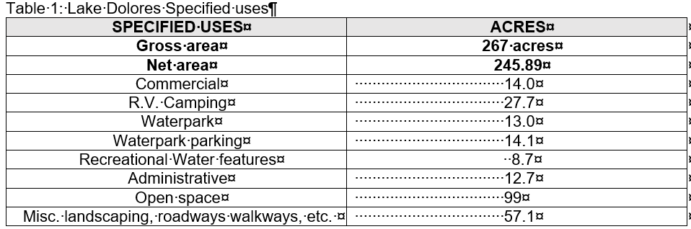

Location:
Lake Dolores is located along Interstate I-15 about 20 miles northeast of the City of Barstow. Access to the property is Via Hacienda Road a frontage road that parallels the I-15, Minneola Road to the south and Harvard Road to the North. The parcel as noted in Figure 1 is bounded by Mountain View Road to the east, Bragdon Road on the west and Cherokee Road to the north which are unpaved and Hacienda Road which is a paved street to the South.

